PROJECT

**REPORT TEMPLATE;**

**BUILD AND EVENT MANAGEMENT SALESFORCE**

**That Helps to Book Visa Slot**

**1. INTRODUCTION**

**1.1 PROJECT DISCRIPTION**

**The project aim is to T real time knowledge for all the student who have base knowledge of salesforce and looking for a real time project .This project will also help to those professional who are in cross technology and wanted to swiched to sales force with the help of this project the will gain knowledge and can include into the resume all well.**

**PURPOSE**

* **The land is laden with bodies. Gore is far and wide. The afflicted lament and plead for compassion. Others cry out for aid.**
* **It might seem to describe a gruesome part of the Littleton, Colorado shooting, but those playing the computer game postal simply label it Entertainment.**

**2. Problem Definition and design thinking**

2.1 **Empathy map**

* An empathy map is a collaborative tool teams can use to gain a deeper insight into customers.

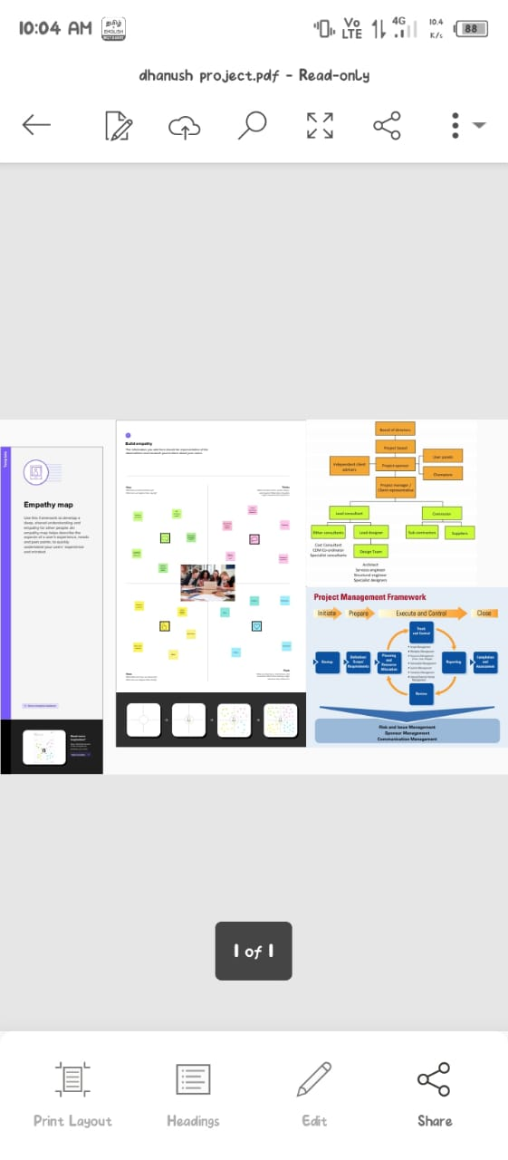

**2.2 Ideation and Brainstorming Mapping**

* **Brainstorming is a method design teams use to generate ideas to slove clearly defined design problem.**

|  |
| --- |
|  |

**3. RESULT**

**3.1 Data Model**

|  |  |
| --- | --- |
| Object name | Fields in the object |
| Object 1 | |  |  | | --- | --- | | Filed label | Data type | | Event | Object | | Speaker | Object | |
| Object 2 | |  |  | | --- | --- | | Filed label | Data type | | Vendor | App manager | | Vendors | App manager | |
| Object 3 | |  |  | | --- | --- | | Field label | Data type | | Start data | Profile | | Event | Profile | |
| Object 4 | |  |  | | --- | --- | | Filed label | Data type | | User | Started | | Event | Object | |

**3.2** Activity and screenshot

**Activity -1 (Event Management)**

Milestern ; users

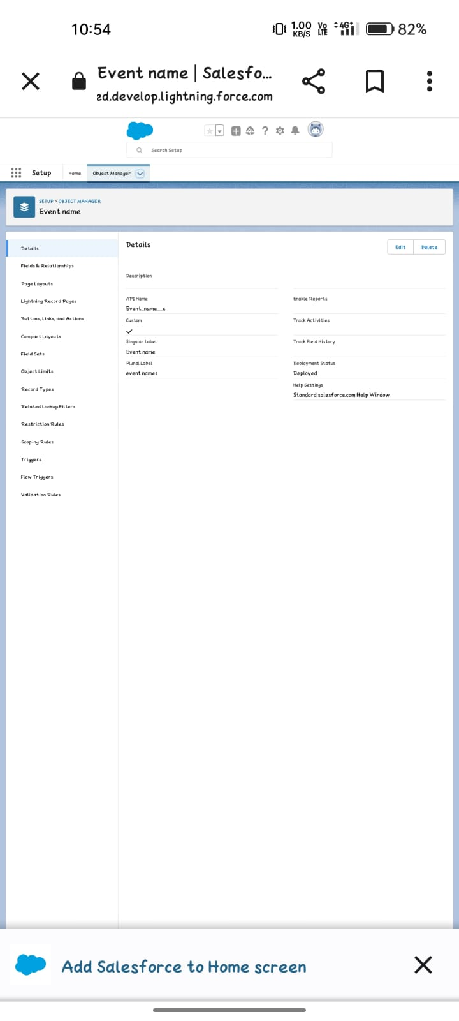

**Activity -2 (Attendee)**

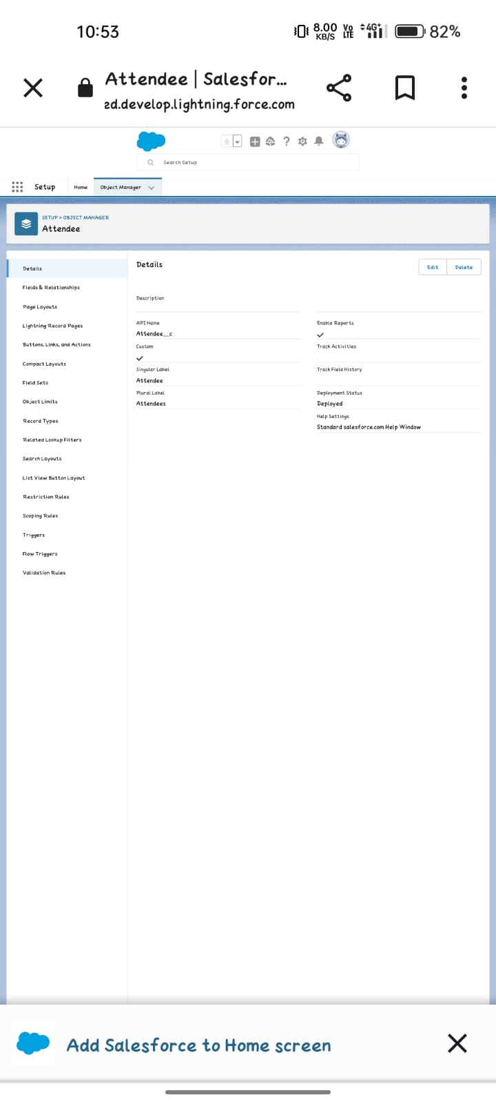

**Activity –3 (speaker)**

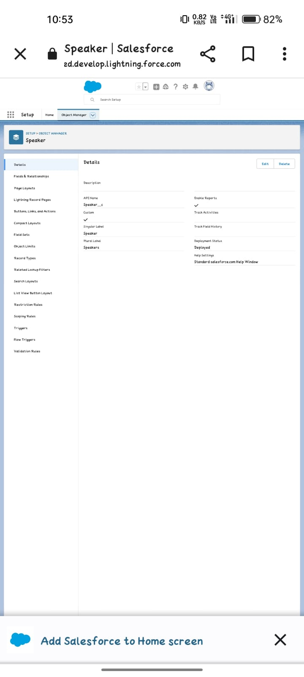

**Activity-4 (Vendor)**

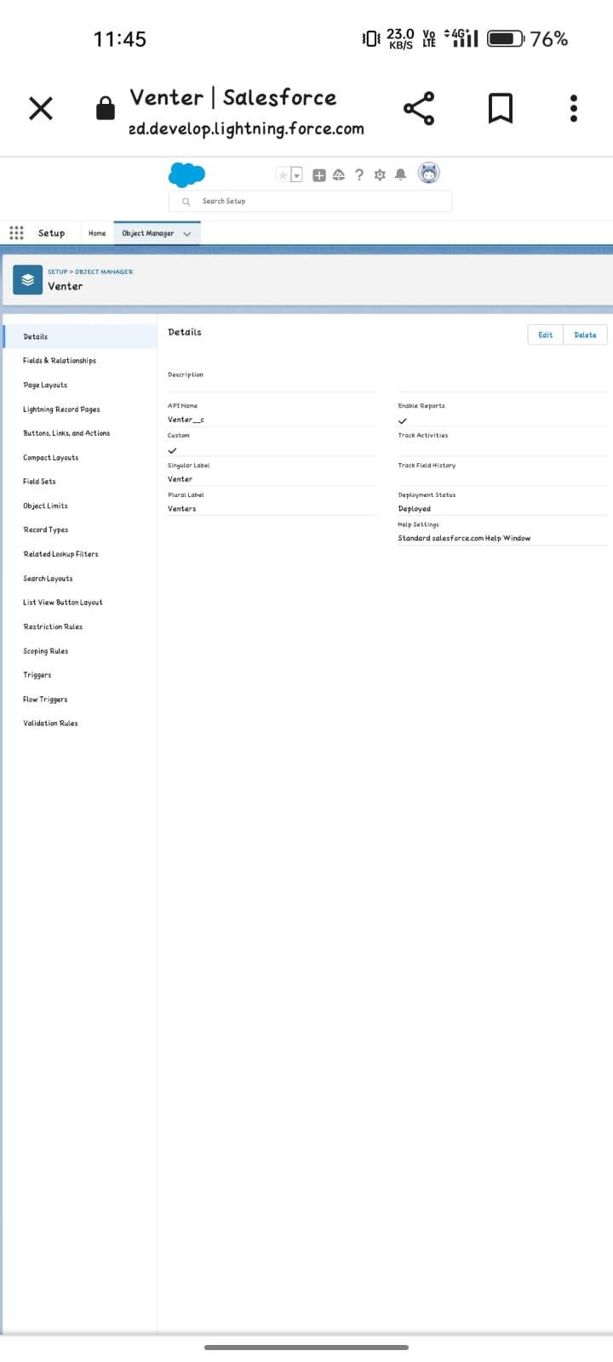

**Milestone 3 – Applications;**

**App Manager**

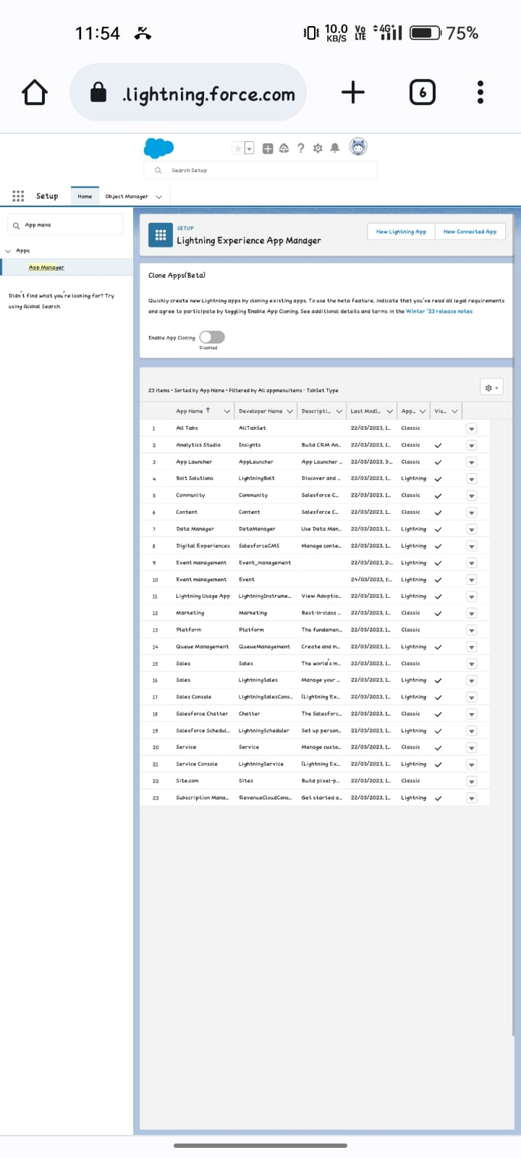

**Milestone 5- Profile:**

**Activity**



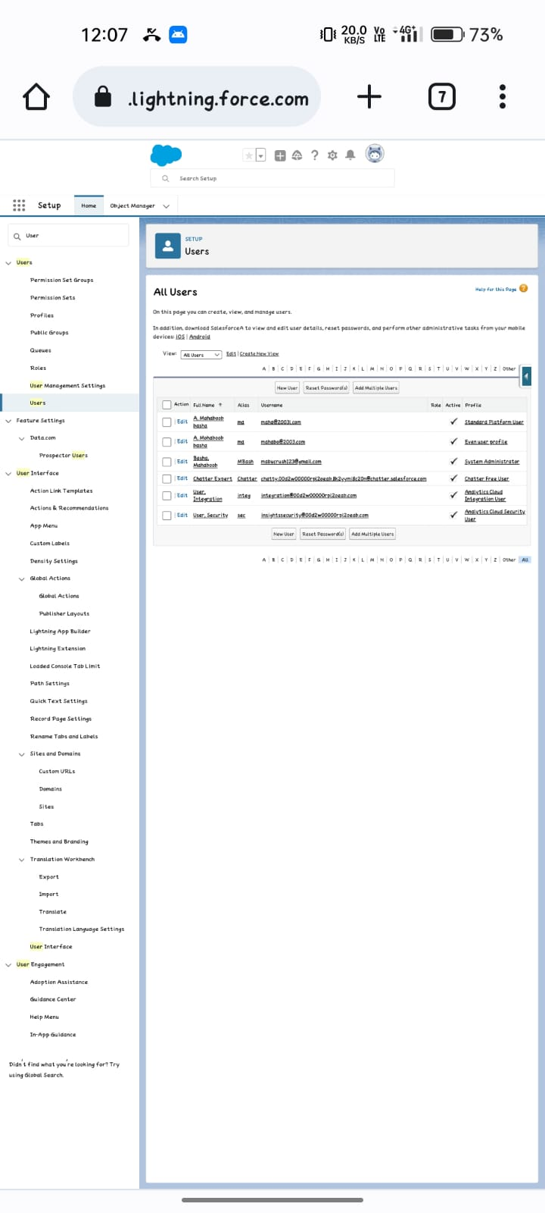

**Description**

* Activity reports is an overview of the workers activities over a period of time, it shows specific tasks, activities, assignment, projects ,and so on that As been done .it’s purpose is to provide a details over view of what a particular worker has been doing .

**4. TRAILHEAD PROFILE PUBLIC URL**

Team Leader-<https://trailblazer.me/id/mbasha91>

Team member- 1 -<https://trailblazer.me/id/dhanushbasker>

Team member-2-<https://trailblazer.me/id/kkumar2087>

Team member-3-<https://trailblazer.me/id/mohan843>

Team member-4-https://trailblazer.me/id/malau25

**ADVANTAGE AND DISADVANTAGE**

**ADVANTAGES**

* Improved energy efficiency; A BMS can help optimise the operation of a buildings heating, ventilation, and air conditional (HVAC) system, lighting, and other electrical system, leading to reduce energy consumption and cost savings.

**DISADVANTAGES**

* The issue is that will be large blind spots because most building management systems do not control smaller equipment. Because the cost to install, maintain, and utilize is so high, most properties with a BMS only have it installed on the major loads, such as large HVAC equipment and lighting.

**6.** APPLICATION

* In a programming context, a build is a version of a program that as a rule, is a pre-release version and is identified by a build number rather than release number.
* Before you can create an application build element you must create .addition have upload a build your origin node.

**7. CONCLUSIO**N

* Event management system is user friendly and cost with activities related to event management life-cycle.
* Provide official take ways and advice for readers who may want to duplicate this event in the future or improve their overall strategy.

**8.** FUTURE SCOPE

* The scope of event management as a career in India is immense as people from diverse it as a career.
* However, companies prefer candidates who have certificates in the allied fields of public relations, tourism, marketing, management , and hospitality.